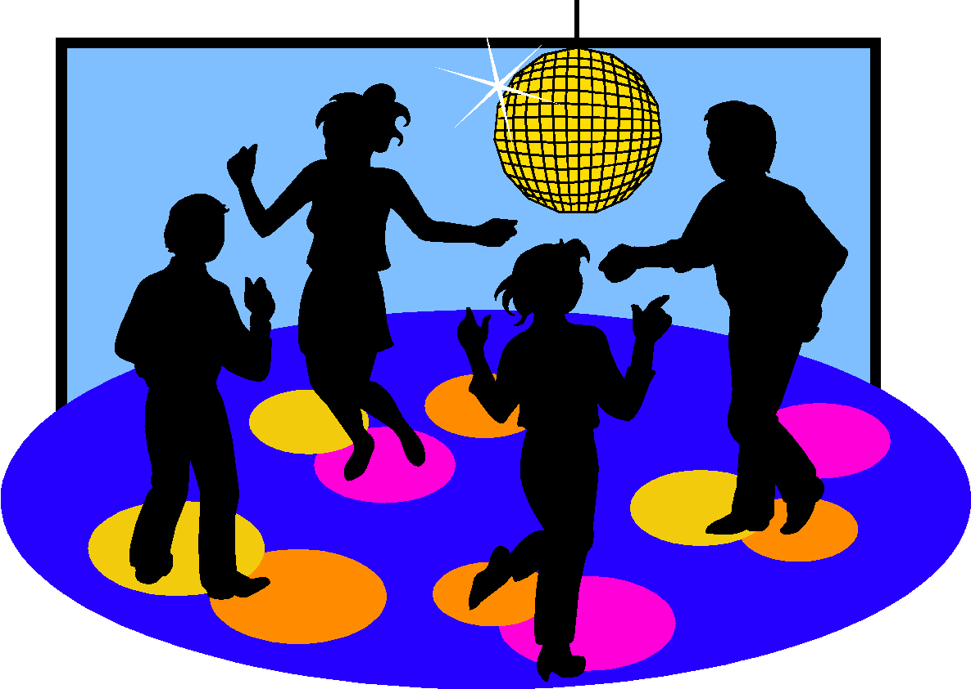
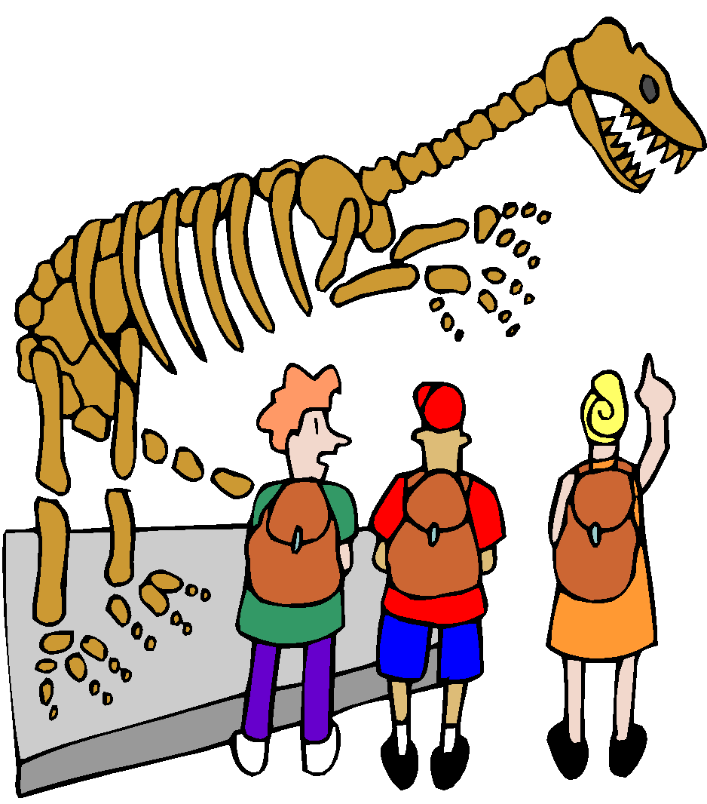
¡MAS PASATIEMPOS!

LOS LUGARES
But we do more than just what we learned yesterday. Below there are different pastimes that many people like to do during their free time.

Grupo 2: (las actividades con el verbo «ir»)
1. ir al cine
2. ir al teatro
3. ir al museo
4. ir a la playa
5. ir al centro comercial
6. ir a los clubs del colegio
7. ir al concierto
8. ir a una discoteca
9. ir al partido de fútbol
10. ir al café
11. ir de compras
12. ir de vacaciones
ir a parques de atracciones
13. ir a una fiesta

Escribe en español: ( Me gusta…)
1 I like to go to parties on Saturday night.

___________________________________________________

2 I like to go on vacation with my family.

___________________________________________________

3 I like to go to concerts in the Summer .

___________________________________________________

4 I like to take a walk on the beach in the Summer.

___________________________________________________

