[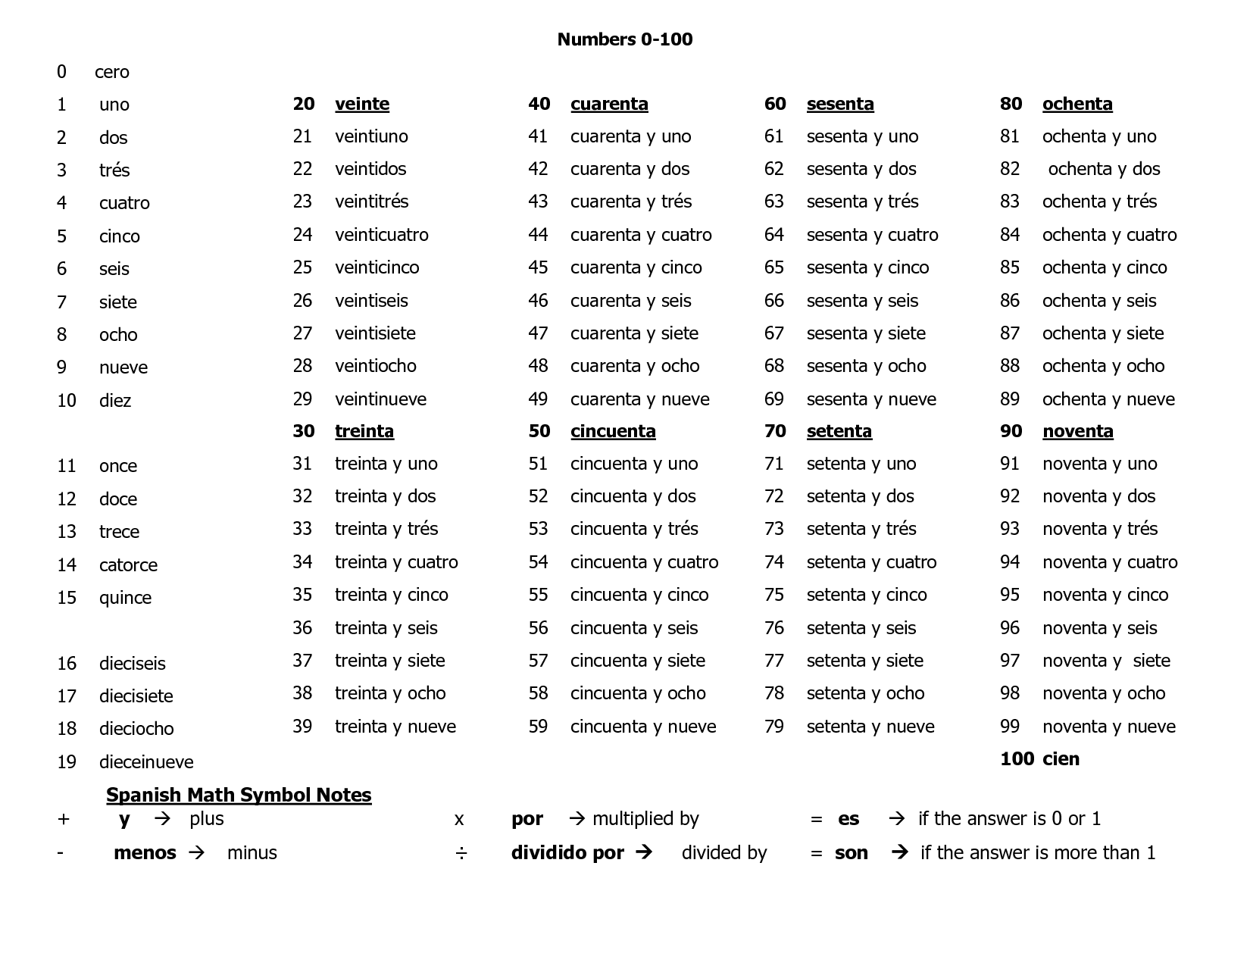](http://www.google.com/url?sa=i&source=images&cd=&cad=rja&docid=q7IOWvrY52K5UM&tbnid=ZGeIk6scY0kloM:&ved=0CAgQjRwwAA&url=http://www.docstoc.com/docs/55807387/Spanish-Math-Symbols&ei=d5tNUqPCHKi6yAHw5IGoAg&psig=AFQjCNE7yyKM9G3Blzk_vpdE0kY33DGPIg&ust=1380904183543776)